|  |  |  |  |
| --- | --- | --- | --- |
| Artifact ID:  CD-005 | Artifact Title:  Concept Development Plan | |  |
| Revision:  1.0 | Revision Date:  15 OCT 2019 | |
| Prepared by:  Jesse Krage | | Checked by:  Joe Hansen |
| Purpose:  Detailed calendar of concept tasks | | |

# Revision History

|  |  |  |  |
| --- | --- | --- | --- |
| Revision: | Revised by: | Checked by: | Date: |
| 1.0 | Jesse Krage | Joe Hansen | 15 OCT 2019 |

# References

|  |  |  |
| --- | --- | --- |
| Artifact ID: | Revision: | Title: |
| CD-004 | 1.0 | Concept Development Path |

# Requirement Breakdown

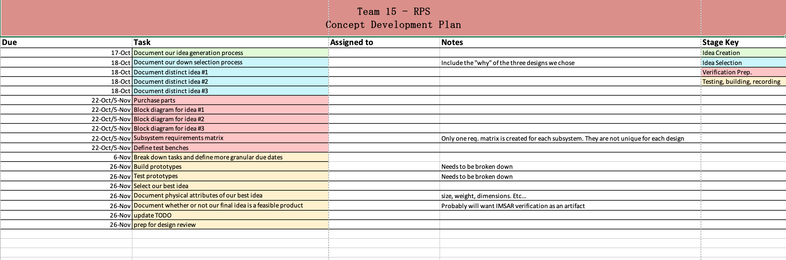This is a more detailed plan going off of our Concept Development Path (see CD-004)

